A Final Rebuttal to the Ministry of Forests Factsheet on the Martin Mars waterbomber
Friday, August 15, 2014 12:00PM
In light of the announcement of the retirement of the Martin Mars waterbombers by the Coulson Group of companies it seemed appropriate to release one final rebuttal to the points the Government used to justify sending these planes into early retirement.
General comments:
The Wildfire Management Branch continually works to ensure that the most appropriate equipment is available to protect B.C. communities from wildfire risks.
Unfortunately, political donations from companies and unsavory relationships between the Forest Service and contractors seems to have won the day.
The Wildfire Management Branch typically responds to 2,000 fires every year across the province. In an average season, airtankers conduct over 600 missions.
The question should have been asked and reported publicly: what do airtankers contribute? When are large air tankers more appropriate than small air tankers? What is the best use for those? How will that change in the future as climate change impacts the fire season? This information has never been determined or released.
It's important to note that aircraft do not put out wildfires, ground crews do. Many airtankers can drop long-term fire retardant on a wildfire to slow its growth and allow ground crews to safely contain it. The Martin Mars cannot drop long-term fire retardant, which is critical in B.C.'s terrain and firefighting conditions.
The USFS lists these properties in their aerial application product training and tactics (http://www.fs.fed.us/rm/fire/wfcs/training/documents/aerialapp.pdf):
Why are wildland fire chemicals used?
• They chemically treat fuels to make them less combustible (long-term retardant)
• They maximize available water supply (foam and water enhancer/gel)
• They improve efficiency of water (foam and water enhancer/gel)
• They reduce fire intensities (retardant, foam and water enhancer)
The Martin Mars cannot drop long term retardant (in BC : Phos-Chek LC-95A) because it cannot land at an airport. However, other aircraft like the Firebosses cannot mix retardants in flight and can only carry a very small amount of foam suppressant to mix with the water they skim. They must land at an airport to take on thermo-gel suppressant or Phos-Chek retardant loads which is of course much slower and generally much farther away than a lake. (http://www.firebossllc.com/news.php).
When you see a Fireboss dumping on a fire after skimming it is only dumping either straight water or foam. The Mars can dump water, foam, and thermogel. It is the only plane that can deliver thermogel suppressants load after load because it can carry and mix the product in flight. It can do so for as long as its fuel is sufficient.
In spring 2014, the Province acquired the contracted services of four Air Tractor AT-802F "Fire Boss" amphibious airtankers that can drop water, foam or retardant on a fire. They can skim up to 3,025 litres of water in 15 seconds from over 1,700 water bodies in B.C. and land at airports, including the Province's 17 airtanker bases. This airtanker group also includes a Cessna Grand Caravan bird dog aircraft.
Because of its size, the Martin Mars can only land on and scoop up water from about 113 bodies of water in B.C.
From 2007 to 2013, the Martin Mars was only deployed on 20 wildfires, or about 0.5 per cent of the 3,476 airtanker missions flown during that period (at a cost of about $4.8 million).
As noted previously, landing at airports is only useful to load long-term fire retardants for small and large planes or thermogel for smaller planes and reduces the frequency and effectiveness of aircraft forced to do so. That is why helicopters and skimmers are used to attack a fire directly, and do so mainly using water, especially when it is first discovered.

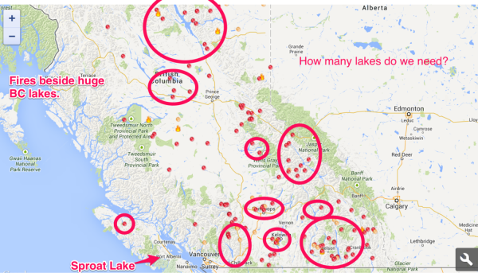

The image above, generated from the Active Wildfires website at the Wildfire Management Branch on August 9. Shows that of the major wildfires around the province the vast majority are concentrated around large lakes many times larger than the Mars home base at Sproat Lake. The Mars also has a travelling support team that can effectively base the planes on any lake in the province according to the need identified. This means it can action far more fires than simply waiting on Vancouver Island for something nearby. And it can respond to far more fires than is implied by the Government comparison thanks to BC’s plethora of very large lakes. As reported in its time in California, and recorded by Coulson Group in their records, the more the Mars is used on a fire and across all fires, the less its cost compared to others.

When drawing a comparison between the Martin Mars and the Fire Bosses that worked the fires in Kelowna in 2003 and in West Kelowna in 2014 respectively, the Fire Bosses delivered more volume and were more cost-effective than the Martin Mars. On the Smith Creek fire (West Kelowna), the Province's Fire Boss group dropped 586,000 litres over 11.3 hours, at a cost of $0.19 per litre. In contrast, on the 2003 Kelowna fire, the Martin Mars dropped 690,000 litres over 28 hours at a cost of $0.63 per litre. The suppressant delivery rate for Fire Bosses in West Kelowna was twice that of the Martin Mars in Kelowna.
According to public data released by Coulson Group, in California at Lake Shasta in 2008, “the Mars produced 436,000 litres in a 7 hour flight period several days in a row.” This would represent an average of 62,000 Litres per hour, whereas this years Smith Creek Fire the 4 Fire Bosses dropped 51,858 per hour. This shows that used effectively, the Mars can outproduce 4 smaller planes while also delivering thermo-gel suppressant that smaller planes cannot.
An ideal scenario would be a combined group of Mars and 2 Firebosses which could bring all of the advantages of both systems to bear on a fire.
The Coulson Group, the company that operates the Martin Mars, did not respond to the Province's offer of an "as when needed" contract for the 2014 fire season.
As is now clear, the “as when needed” contract, where the Mars would only be paid for service when called, was not sufficient to sustain the operation of the Martin Mars service and the many employees it supported. The seasonal contract of $600-$750,000 that would sustain the Martin Mars service was a fraction of the $2.5 Million seasonal contract obtained for the FireBosses and ConAir.
Over the past six weeks, the new Fire Boss aircraft have actioned more fires than the Martin Mars did in six years.
This statement is a matter of priorities not capabilities. If stationed in the interior, the Martin Mars could be sent to far more fires than what occur in the west coast of the Coastal Fire Centre. If used to its full capacity for overwhelming direct and initial attack of fires, the cost per gallon for the Mars is significantly reduced and the cost of containing and mopping up a fire is potentially reduced as well. The Mars also has the unique ability to coat homes and neighbourhoods with fire suppressant thermogel proactively if a major fire threatens an urban interface. The Mars would only be able to do this, however, if it was deployed to an area near the fire. This would require it being proactively deployed in areas most likely to suffer this fate. This was a recommendation made in 2008 after the Fire Storms near San Diego. It was also the reason for the unanimous UBCM recommendation in fall 2013.
The Fire Boss is just one type of airtanker. Including these new aircraft, the Wildfire Management Branch has the following 31 aircraft available for fighting wildfires in B.C.: 16 airtankers, 8 bird dogs, 6 medium-lift helicopters and 1 light-lift helicopter on long-term contract.
It is worth noting that of the large airtankers in the BC fleet none are skimmers. They must load their retardant (less than half the 27,000L of the Mars) or water/foam at an airport. This severely reduces their air return time to a fire compared to a skimmer like the Mars which can keep refilling with water for 3 hours until its fuel is exhausted. Further, the largest airtankers in the ConAir fleet, the L-188C Electra and Convair CV580 are of similar vintage (1957 and 1947 respectively) to the Martin Mars fleet (1945) and require significant maintenance to maintain their flying ability. They are extremely well maintained to Transport Canada standards, as is the Martin Mars.
The province can bring in additional contract helicopters as needed. Over 100 helicopters are currently helping to fight wildfires throughout B.C. Depending on the level of wildfire activity in the province, the government may request assistance from other jurisdictions through the Mutual Aid Resources Sharing Agreement, which allows for the movement and sharing of firefighting resources (including aircraft) between B.C. and other provinces and territories.
Requesting assistance is very expensive and also takes away resources from the jurisdictions and communities from which they are taken. If there are any demands for those resources from their home communities, they must return. BC should be resourcing its firefighting service sufficiently with BC based companies so that they are more prepared for the extremely challenging situations we have often faced in the past many years. In 9 of the past 11 years (including 2014) BC has gone over its $63 Million budget. The Forest Service expects fire activity to increase in time with climate change. We must bolster our resources and capabilities. The Martin Mars is a proven and effective insurance policy.
Operations and technical capabilities:
The targeting accuracy of the Fire Boss allows firefighting crews to take a more aggressive approach to fighting a wildfire.
Because the Martin Mars flies slowly over a fire, it can have very high accuracy especially when directed by Bird Dog aircraft. A combined team of Fireboss and Mars over an aggressive fire as recommended at a 2011 Northwest Aviation conference would be a show stopper and help crews get a handle on aggressive fires quickly. (Pictured below)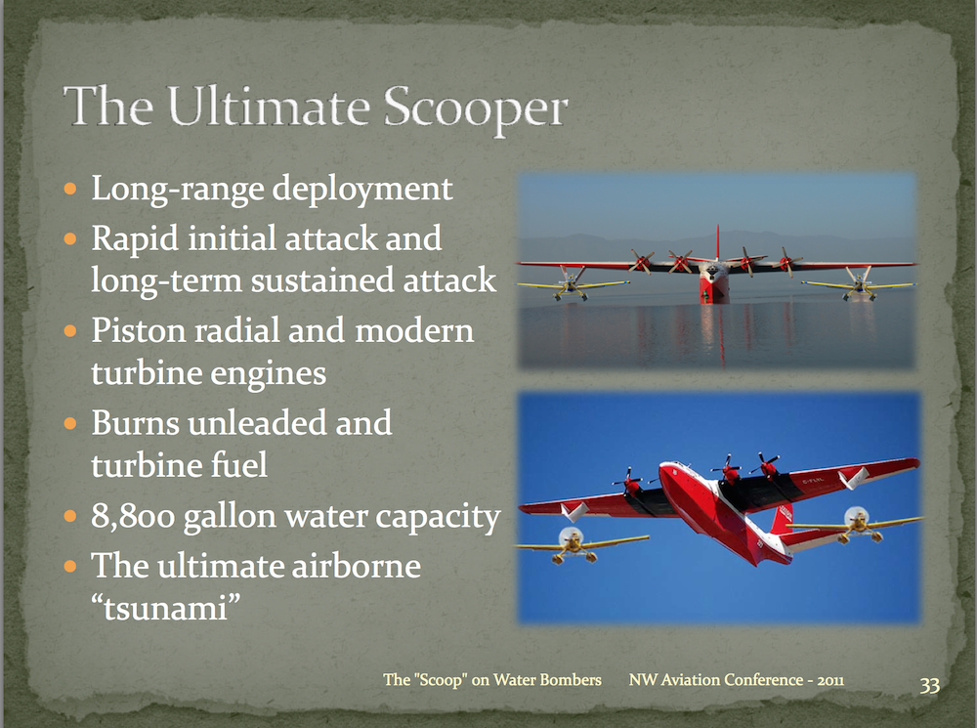

If one of the Fire Boss aircraft were to experience mechanical difficulties, the other three aircraft in the group would remain in service.
There is only one Martin Mars in B.C. The mechanical failure rate of the piston engines used by the Martin Mars is much greater than that of modern turbine engines.
While the challenges of older technology on the Mars are undeniable, the professionalism and speed of the maintenance crew that take care of the bomber is crucial. The Mars has rarely been “down” for more than a day in its history when called upon to fight a fire. The crew can even replace an entire engine in a matter of hours as they stock multiple engines for the planes at their base. As we’ve seen most recently in California and Mexico, the Mars has proven it can be on top of a fire constantly and consistently for days on end without fail.

Because of its relatively slow airspeed and large size, the Martin Mars is more difficult to integrate into B.C.'s firefighting operations, including close air support for firefighters on the ground.
The Martin Mars' large drop pattern can sometimes make it unsafe to use when providing close air support for ground crews. Firefighters on the ground have to stop work until drops are completed, which may increase the risk of a fire escaping during the critical initial attack stage.
The Mars large drop pattern (4 acres) can also create a situation where an entire fire is prevented from becoming a major concern which ultimately protects firefighters and reduces their work in fully containing and mopping up the fire. Further, in its role as proactive protectant in communities on urban interface fires, the Martin Mars could be deployed after a neighbourhood has been evacuated so as to ensure the safety of all involved and still protect those neighbourhoods from being ravaged by fire.
Although the Martin Mars has a tank capacity of 27,250 litres, the average drop volume is 19,000 litres with an average turnaround time of 19 minutes. The average turnaround time for the Fire Bosses is seven minutes.
As detailed in previous responses, the sheer size of the Martin Mars means even though it (as any plane) cannot take a full load of water when also fully loaded with fuel, it’s turnaround time and volume is still sufficient to outperform 4 Airbosses. (62,000L/hr vs 52,000L/hr). Again, fielding a combined force of Airbosses and the Martin Mars would give the best of both worlds.
The provincial aircraft fleet must be repositioned constantly during the fire season to be ready for anticipated fire starts in high- risk regions. This strategic prepositioning reduces firefighting costs overall.
The ability to reposition the Martin Mars is limited due to its limited airspeed, its need to land on larger bodies of water, its inability to land at airports and its refuelling requirements when it's working away from its primary base at Sproat Lake.
Repositioning the Martin Mars is more challenging than repositioning smaller aircraft because of the significant logistical support that it requires.
There is no doubt that with a large plane like the Martin Mars comes larger logistics challenges. However, Coulson Group has proven it can have the plane repositioned and ready to fly in as little as a day. If the Mars was stationed on an interior lake for the summer it could be much more easily repositioned to other lakes in a very short amount of time compared to having to come over from Vancouver Island.

The Wildfire Management Branch has the option to split up the Fire Boss group and attack multiple targets at once. This is especially valuable when fighting a series of fires sparked by intense lighting storms.
There is no doubt the Wildfire Management Branch needs as many resources as possible. That is why forcing the Martin Mars into retirement in a time of need is so galling. The $63 Million budget for Wildfires is clearly insufficient. The $690,000 contract to keep the Mars is a fraction of even that inadequate budget. The BC Governments own research shows the need for firefighting resources is only going to increase over time. We should not be forcing assets into retirement.
The new Fire Boss aircraft are versatile, efficient and effective in suppressing B.C.'s wildfires. As of July 21, the Fire Bosses had flown 230 hours suppressing fires in B.C., dropping more than two million litres of suppressant on wildfires.
It is interesting to note that this statement includes the words “suppressant”. While other points have made much of the fact that the Mars cannot drop “long term retardant” on a fire. This statement indicates quite clearly that the requirements to drop suppressants on wildfires are enormous. Just for interest sake, one Martin Mars at 62,000L/hr, could drop 2 million litres of suppressant, including Thermo-Gel 100% of the time, in 32 hours flight hours. Two Martin Mars (if Phillipine Mars were returned to service and upgraded as has been Hawaii Mars) could deliver 2 million litres of Thermo Gel suppressant in as little as 16 hours.
In the unlikely event an airport was nearby allowing a turnaround and reload time of about 30 minutes for a FireBoss to reload Thermo-Gel, it would take a fleet of 40 Airbosses to deliver the same amount of thermogel to a fire as the two Martin Mars.
Costs:
The Province does not own any fixed wing aircraft or helicopters. The four new Fire Bosses are operated by Conair Group of Abbotsford for $2.5 million per fire season, plus an hourly flying rate. This contract provides for the use of all four airtankers and a bird dog aircraft for 100 days per fire season.
In 2013, when the Wildfire Management Branch last used the Martin Mars, the season rate was $672,300 with a flying time cost of $4,000 per hour for the first 45 hours and $18,800 per hour for any additional hours. This rate does not include fuel.
The hourly operating rate (including fuel) for all four Fire Bosses combined is $2,000 per hour less than that of the single Martin Mars. This cost difference becomes a $17,000-per-hour disparity if the Martin Mars was flown over 45 hours per year.
Premier Christy Clark said this July when her riding was under evacuation orders from the Smith Creek Fire said “the province will not stop spending money on fighting fires just because it is expense”. There is no doubt the Mars is more expensive than other assets. However, it has proven over its 54 years of service to be worth that expense especially in times of great need. And with new technology and thermo-gel added to the Mars capabilities that expense has been further justified to save homes and communities from damage.
With a seasonal contract rate a fraction of what the Airbosses require, it is also a very small amount to pay in order to have an insurance policy ready and waiting and to sustain very well paying jobs in BC.
The Martin Mars aircraft also tracks its use and costs extremely closely so that the Forest Service has an exact accounting of the cost and effectiveness of the plane. http://martinmars.com/pdf/martin_mars_brochure.pdf
The "cost per litre delivered" on the West Kelowna by the Fire Boss in July averaged $0.19 per litre. In 2003, the Martin Mars cost per litre on the Kelowna fire was $0.63 per litre. The historic average cost per litre for the Martin Mars is $0.48 per litre.
The cost of fuel per hour for all four Fire Bosses combined is less than half the cost of fuel per hour for the single Martin Mars. The cost of repositioning four new Fire Bosses combined is about $1,200 per day. The cost to reposition the Mars was about $12,000 per day, or 10 times that amount.
Given the unique capabilities and capacity of the Mars the taxpayers of this province, as witnessed through this petition and through the UBCM are not adverse to paying what is needed to give the best chance to protect forests, communities, homes, and firefighters.
There is also a currently unknown component of whether using the Mars more, which would reduce its cost more towards its average, would ultimately save the Province money containing and mopping up those fires and saving the ground firefighters the stress and fatigue of fighting massive fires that could have been kept much smaller.
The Martin Mars' operational limitations make it difficult to sell surplus availability of this aircraft through mutual aid agreements. In contrast, the Fire Boss aircraft have already been in demand for deployment outside of B.C. earlier this season when they were not needed here. The Fire Bosses were deployed to the Northwest Territories earlier this summer, which recovered $287,000 for the Province.
In just the past decade the Mars has been deployed to California, Mexico and Alberta. In times of need of other jurisdictions, having the Mars stay home could also mean freeing up smaller aircraft to be deployed elsewhere.

